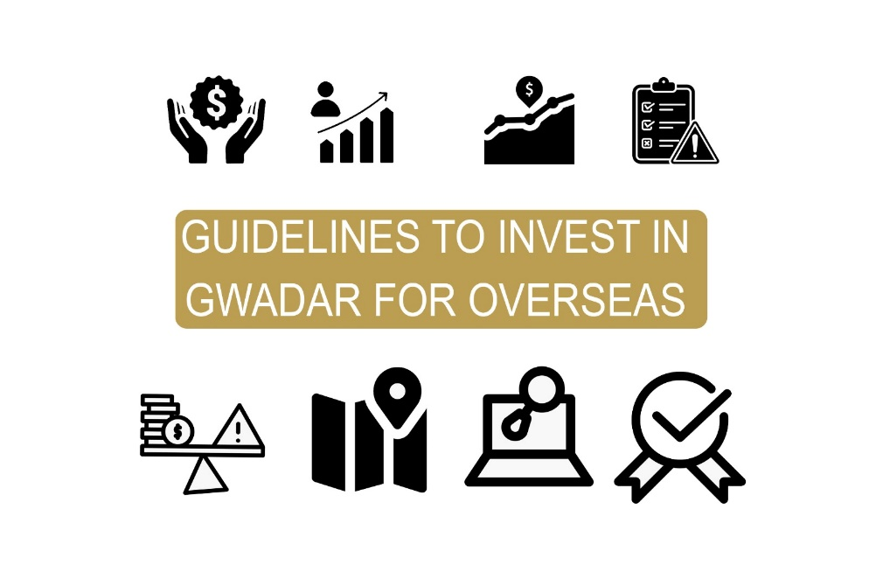
Guidelines to Invest in Gwadar for Overseas:
Investing in Gwadar, Pakistan from the Overseas can be a promising opportunity with higher returns, but it is important to consider several factors before making a Just decision whether to invest in right place, and right time with equitable investment. Here are some vital factors to be consider:


- Research the Gwadar market:

Gwadar is a developing city and its Real Estate market is growing rapidly. Research the market trends, the current prices, and the potential return on investment. Also visit website of CPEC, GDA for more knowledge.

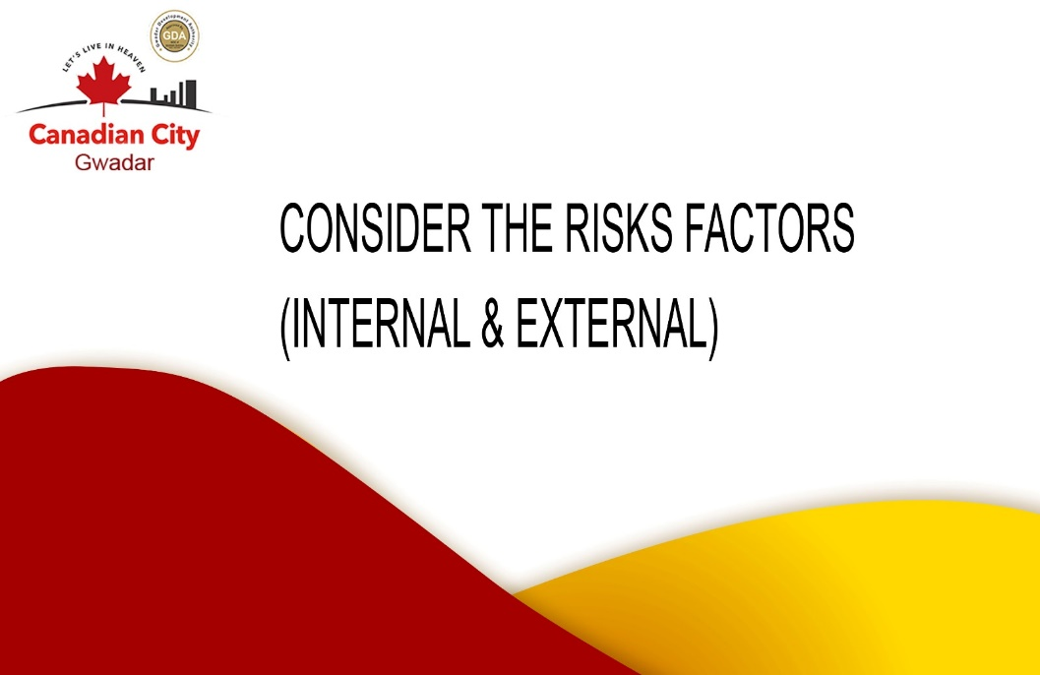
- Consider the risks factors (Internal & External):

Investing in any foreign market coupled with its own set of risks, including political and economic stability, currency exchange rates, and property ownership laws. It's important to carefully assess these risks before investing.

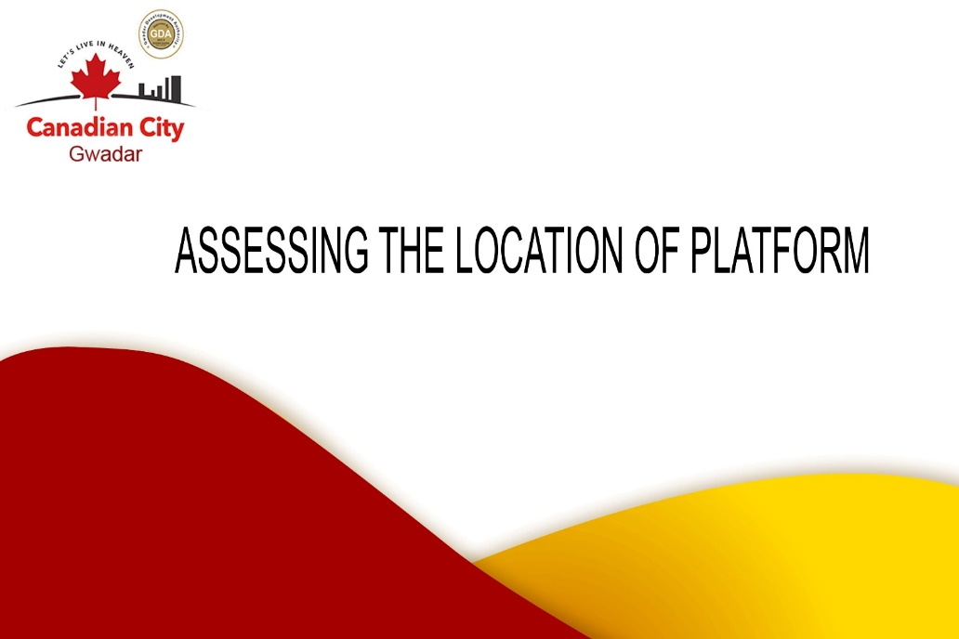
- Assessing the location of platform:

Location of any project is Essential key point for choosing any project, assess the local facilities/amenities (highway, airport) nearby and roads infrastructure of that project. The location of a property has a direct impact on its value, rental yield and capital appreciation potential.

- Is the investment platform having N.O.C from Regulatory Body (GDA)?
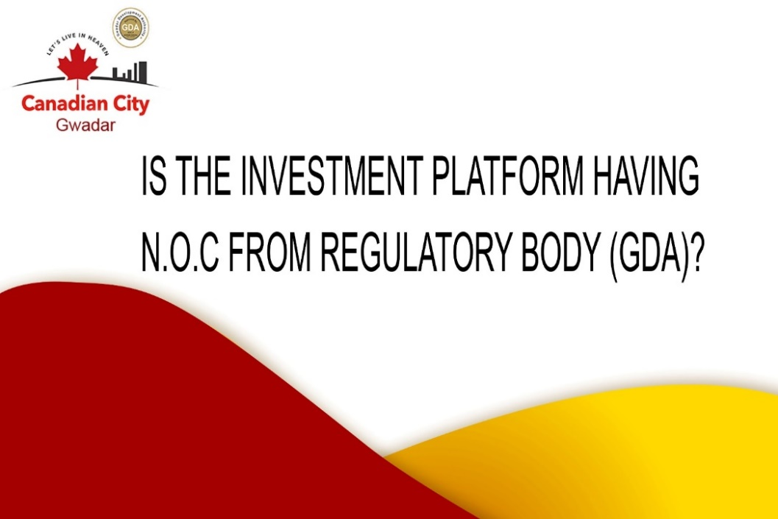
There are several online investment platforms that can help you invest in Gwadar from any country. Do your research and choose a platform that has a good reputation and is regulated by the relevant authorities. Find the N.O.C issued by Gwadar Development authority at the official GDA website.

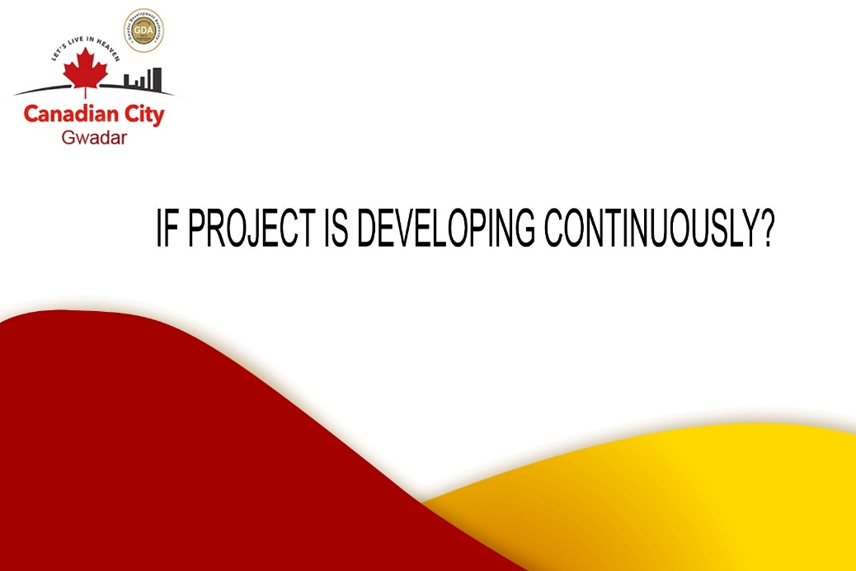

- If project is developing continuously?

Development in any project either residential or commercial totally depends on progress of that particular platform and on the development of Gwadar itself, and it is an on-going process, you must check out the completion of projects in the past 6 months to 1 year on the website of Gwadar.



- Market Competitive Analysis:

Do competitive market analysis of that certain property with other projects within Gwadar before paying the desired price offered by others for that specific location.



- Value for Money:

Before investing in any project make sure it’s worth spending on and would be profitable in near future.

